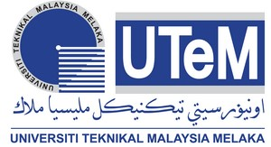
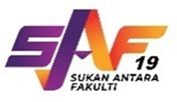
SUKAN ANTARA FAKULTI 2025
UNIVERSITI TEKNIKAL MALAYSIA MELAKA

SEKRETARIAT SAF UTeM 2025

PUSAT SUKAN

PEJABAT HAL EHWAL PELAJAR DAN ALUMNI

UNIVERSITI TEKNIKAL MALAYSIA MELAKA

HANG TUAH JAYA

www.utem.edu.my 76100 DURIAN TUNGGAL
DITERIMA PADA | STUDENT MEDICAL HEALTH REPORT | SAF 05/06
Name :
No. Matrik Student :
MEDICAL SELF-DECLARATION
TICK( / ) AT APPROPRIATE BOX
Have you contacted or receiving treatment for the following illnese:
Yes
No
i. Asthma
ii. Heart Attack
iii. High Blood Pressure
iv. Diabetics
v. Epilepsy
vi. Disfigurement
STAF DECLARATION
IC NO. :
I hereby declare that all information declared are truthful.
Date : -------------------- Staf's signature in :
the presence of doctor ----------------------
DOCTOR'S MEDICAL REPORT
- Brain Alertness OrdinaryExtraordinary
- Heat Beat OrdinaryExtraordinary
Sistolic
Mmhg
Diastolic
Mmhg
- Blood Pressure
Extraordinary

Extraordinary

Extraordinary
- Heart
Ordinary
Ordinary
Ordinary
Comment :

I hereby declare that the staff:
Does not suffer from any illness, certified healthy and fit to take past in SAF UTeM 2024
Suffer illness of and allowed/not allowed to take
part in SAF UTeM 2025.
Doctor's Name |  | Singnature | STAMP
Department |  |  | STAMP
Date |  |  | STAMP
Due Date : 5 November 2025 (Fasa 1)
13 November 2025 (Fasa 2)
Check UpDate : 28 Oktober - 31 Oktober 2025 (Fasa 1)
3 - 6 November 2024 (Fasa 2)

